Stag Hunt Inn
Wednesdays
Is
Penny’s Pie and Mash Night
2 for £20

To Eat In
Or Takeaway
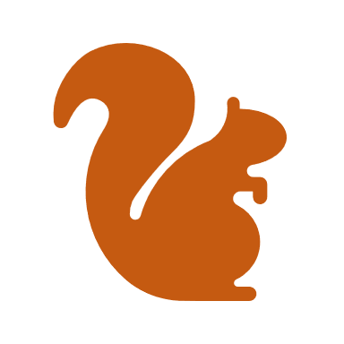
Steak and Ale
Chicken leek and Bacon
Egg and Bacon
Halloumi and Roasted vegetable
Vegan Cashew nut and Butternut squash tart
Phone 01872 863046 to pre order or book a table

